**ST.ANN’S COLLEGE OF ENGINEERING & TECHNOLOGY**

**DEPARTMENT OF ELECTRICAL AND ELECTRONICS ENGINEERING**

**(Accredited twice by NBA, IE (I) Kolkata, & NAAC With “A” GRADE approved**

**by AICTE, NEWDELHI & Permanently AFFLIATED TO J.N.T.U.K,KAKINADA)**

**2010-2014**

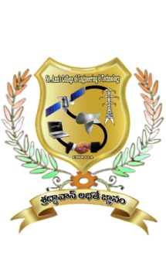

**CERTIFICATE**

This is to certify that the project work entitled **“Power Quality Improvement of Wind Energy Grid Connected System Using STATCOM Current controller”** thatis being submitted by **Mr/Ms.** bearing **Roll. No:** in partial fulfilment of the requirement for the award of the degree of **Bachelor of Technology in ELECTRICAL & ELECTRONICS ENGINEERING** of **Jawaharlal Nehru Technological University Kakinada, Kakinada** isa record of bonafide work carried out by himunder my guidance and supervision during the academic year 2013-2014.

Viva voce date:

**Mr.B.V.S.PRAHASITH DASARI, M.Tech Mr.S.V.D.ANIL KUMARM.Tech,( Ph.D)**

**PROJECT GUIDE HEAD OF THE DEPARTMENT**

**EXTERNAL EXAMINER**